Admission Notice

FOOD CRAFT INSTITUTE

Established in 2010
(Sponsored by Ministry of Tourism, Govt. of India and Deptt. of Tourism, Govt. of Assam)
Affiliated to National Council for Hotel Management and Catering Technology, Noida
Food Craft Institute, Samaguri, P.O. Rangagora (N.H. – 37) Nagaon, Assam, Pin - 782140
Contact No. 8472847144, 7002294964, 7002899957,9864888044
Website – www. foodcraftinstituteassam.in, Email : fcinagaon@gmail.com
Course Offered:
1 ½ year Diploma in following trades: -
Course Course fee
Food production Rs. 44,880/-
Food & Beverage Service Rs. 39,600/-
Front Office Rs. 39,600/-
Housekeeping Rs. 39,600/-
Bakery & Confectionery Rs. 44,880/-
Examination and other fee charges = Rs.5, 900/- (approx.)
Uniform expenses = Rs. 6,000/- (approx.)

Candidates who have passed 10+2 in any stream are eligible for the course. Candidates who are interested for this course should not exceed 25 years as on 1st July”2019. (30 years for S.C/S.T).

Deserving candidates belonging to Assam will be considered for sponsorship by the Department of Tourism, Govt. of Assam upto 50% of the total fee.

Academic session commences on 29th July’2019. Admission Form and prospectus can be purchased from the Institute @ Rs. 200/- Forms may be downloaded from Institute website.
Hostel facilities available for both boys and girls @ Rs. 2,500/- per month.
Course includes 6 months Industrial Training at hotels. Training Placement facilitated 100% by the Institute.
Some of our successful alumni:

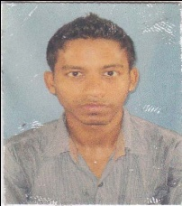


RATUL BORUAH (Year – 2010-11) RINEE MOCHAHARY (Year 14-15) MUKUL PADUN (Year 12-13)
Hotel Kalifa Global ,Kuwaite Hotel Marriott, Hyderabad Jumeirah Village Circle,Dubai

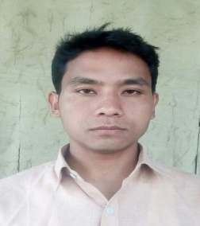


PAPU HAZARIKA (Year -11-12) VIVEKANANDA MEDAK (Year 15-16 ) PRATIKSHA BORA (Year 16-17)
P & O Cruise Ship, Australia Mess Staff, Indian Air Force Novotel Imagika Khopoli,Mumbai
Principal, Food Craft Institute

